Osemsmerovky – vianočné Meno: ...............................................................

2.

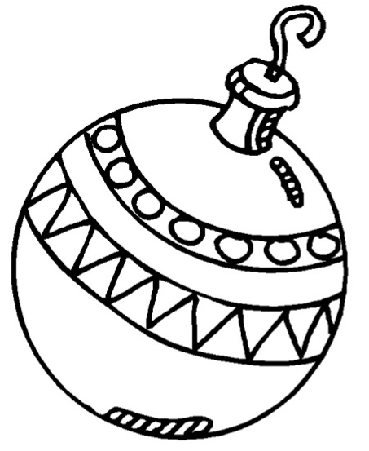















1.

Vyškrtaj všetky slová a potom daj do krúžku nevyškrtané písmená. Tie tvoria čítaním po riadkoch tajničku.

|  |  |  |  |  |  |  |  |  |  |
| --- | --- | --- | --- | --- | --- | --- | --- | --- | --- |
| S | M | R | Á | D | N | E | L | A | K |
| Y | V | I | V | I | K | Ľ | Á | R | K |
| B | K | I | S | C | K | L | Á | V | A |
| U | S | A | A | K | E | S | E | N | O |
| Z | U | T | R | T | A | T | E | P | Ť |
| A | K | R | O | M | K | M | E | L | S |
| J | K | O | S | Y | Z | Y | A | T | E |
| A | O | T | S | E | M | T | B | E | Š |
| C | O | O | M | A | K | C | A | R | P |
| E | N | E | M | A | K | A | Ž | O | K |

STO, TORTA, KOSY, MRAKY, KALENDÁR, KRÁSA, MISKA, ZUBY, LATKA, KIVI, KRÁĽ, LESK, LÁVA, ŠTETEC, SENO, ŠESŤ, NOSY, PLTE, ZMENA, PRACKA, ŽABA, KOŽA, MESTO, KAMENE, ZAJACE, ZEM,

MORKA, KUS

|  |  |  |  |  |  |  |  |  |  |
| --- | --- | --- | --- | --- | --- | --- | --- | --- | --- |
| P | K | A | I | L | U | H | E | N | S |
| A | O | A | M | A | L | T | U | T | A |
| P | Z | K | Ň | E | M | E | R | R | N |
| M | A | A | O | A | S | O | Č | H | K |
| A | R | L | M | J | M | E | S | O | Y |
| L | B | A | I | A | A | E | B | T | A |
| M | O | K | I | C | J | R | S | I | C |
| J | I | S | O | E | A | A | O | T | E |
| Á | U | E | M | N | E | I | V | E | V |
| M | U | Ž | R | A | E | R | A | D | U |

VIE, DETI, DVAJA, KOBRA, SÁNKY, VEC, DAR, LAMPA, SNEHULIAK, STROM, SOVA, KRUH, TRH, MÁJ, TLAMA, LEČO, OSEM, SKALA, REMEŇ, MOST, OSA, OBRAZ, PALICA, MUŽ, JAMA, SEJEM, KONE, CENA, MUSIA

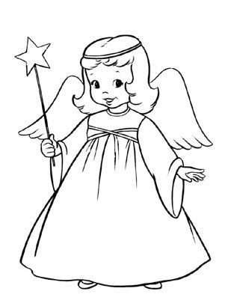

**TAJNIČKA:**

VIANOCE SÚ ......................................................

................................................................................................

